ASR installation
Depend on server zone we have to install the package.
Package is different for every zone.
1.we have to remove noexec in /tmp director on Linux server
And remount /tmp
mount -o remount, /tmp
2.we have to copy the ASR file into Linux server.
Microsoft-ASR_UA_9.61.0.0_RHEL7-64_GA_18Mar2024_Release.tar.gz
3. untar the Microsoft file
tar -xvf Microsoft-ASR_UA_9.61.0.0_RHEL7-64_GA_18Mar2024_Release.tar.gz
4. install ASR agent.
sudo ./install -r MS -v VmWare
it will ask permission keep press enter to take default.
It will take some time to install the agent
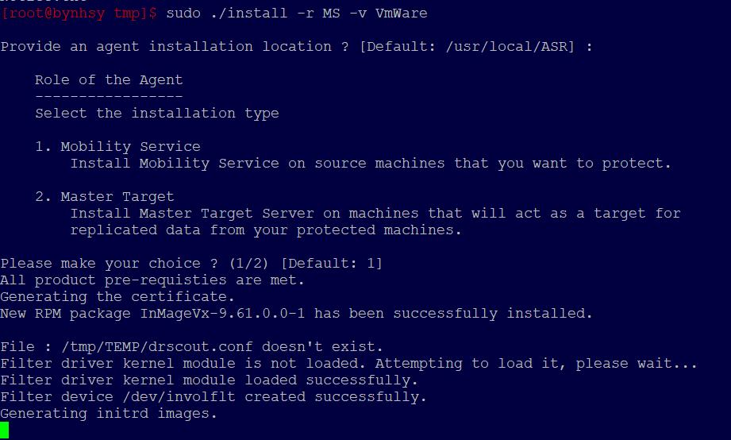
5.Once installation is completed check the version status
cat /usr/local/.vx_version
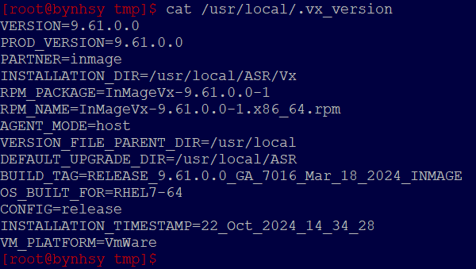
6. To check the status
cd /usr/local/ASR/Vx/bin/ (--path)
./status
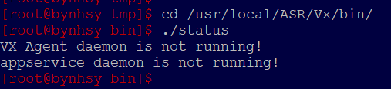
7.To start
./start
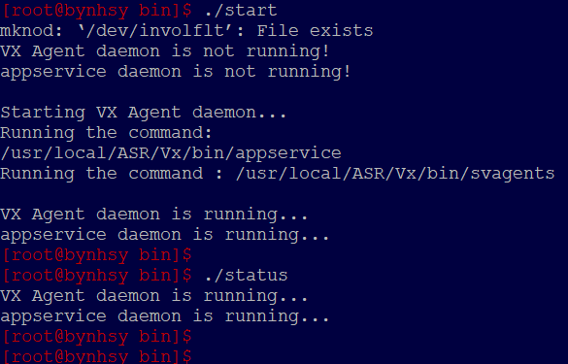
8.To replicate the ASR in portal
After the installation is finished, the Mobility service must be registered to the configuration server. Run the following command to register the Mobility service with the configuration server.
create credentials path in /var/passphrase
CSIP =replicated IP
/usr/local/ASR/Vx/bin/UnifiedAgentConfigurator.sh -i <CSIP> -P /var/passphrase.txt -c CSLegacy

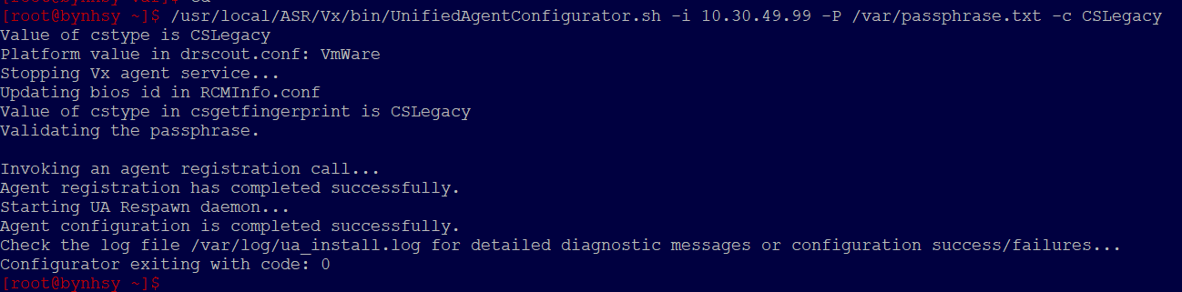

Environment | Hostname | IP
Controlled | BYDE280UZ39 | 10.30.65.24
DMZ | BYDE277142O | 10.30.49.99
Enterprise | BYDE276ISYQ | 10.30.87.166
Protected | BYDE279U4JB | 10.30.97.15
Secure | BYDE2782CLK | 10.30.17.46

NOTE:- please perform uninstallation if only required.
9.enter the path /usr/local/ASR.
cd /usr/local/ASR
10. for uninstall ./uninstall.sh -Y
./uninstall.sh -Y
